Young Green Staff

TEACHER’S HOURS MAY VARY BASED ON THE CHILDREN’S SCHEDULES

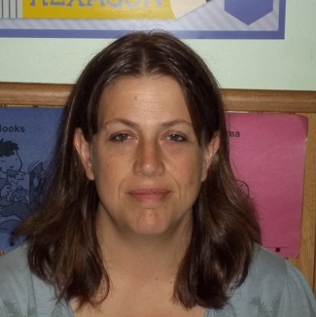

Dawn




Nicollette Toni

Old Green Staff

TEACHER’S HOURS MAY VARY BASED ON THE CHILDREN’S SCHEDULES

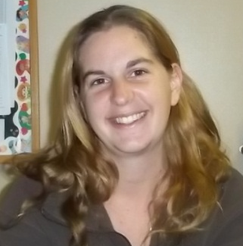
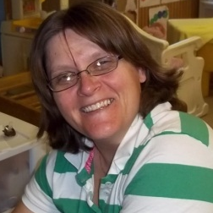

Jenny Kelly S.

Blue Staff

TEACHER’S HOURS MAY VARY BASED ON THE CHILDREN’S SCHEDULES


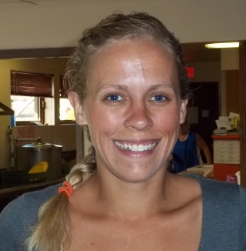
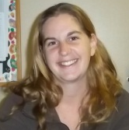

Jenny Shauna Vanessa

Purple Staff

TEACHER’S HOURS MAY VARY BASED ON THE CHILDREN’S SCHEDULES



Vanessa Dawn Ashley R.

4K 12:35 p.m. - 3:40 p.m



Ms. Elder

Orange Teachers

TEACHER’S HOURS MAY VARY BASED ON THE CHILDREN’S SCHEDULES



Marcie

Sunshine Staff

TEACHER’S HOURS MAY VARY BASED ON THE CHILDREN’S SCHEDULES


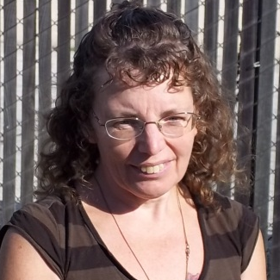
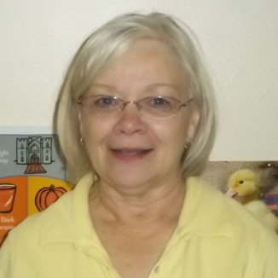



Carolyn Carol Pam Cynthia

Ashley G.

Yellow Staff

TEACHER’S HOURS MAY VARY BASED ON THE CHILDREN’S SCHEDULES






Ashley R. Charity Carol Kay

Ashley H.

Fluffy Cloud Staff

TEACHER’S HOURS MAY VARY BASED ON THE CHILDREN’S SCHEDULES


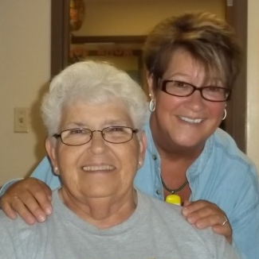
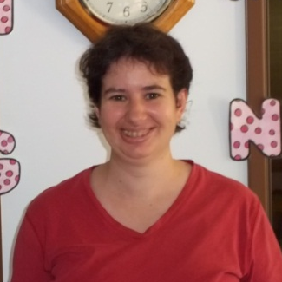

Darlene and Eileen Sheila Brenda

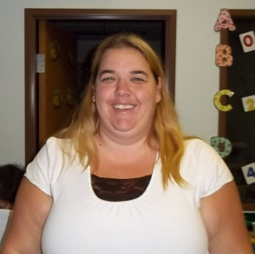

Sara Charity

Support Staff


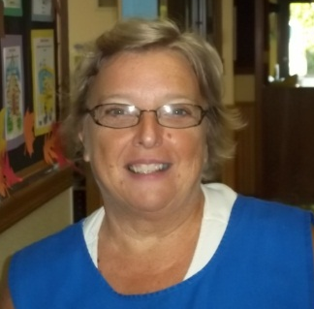

Suzette: Office Cooker Cindy
M-Th 7:00-1:00 5:00-1:00
Fri 11:00-5:00

Maintenance

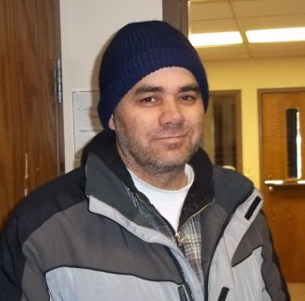

Ron Mike

